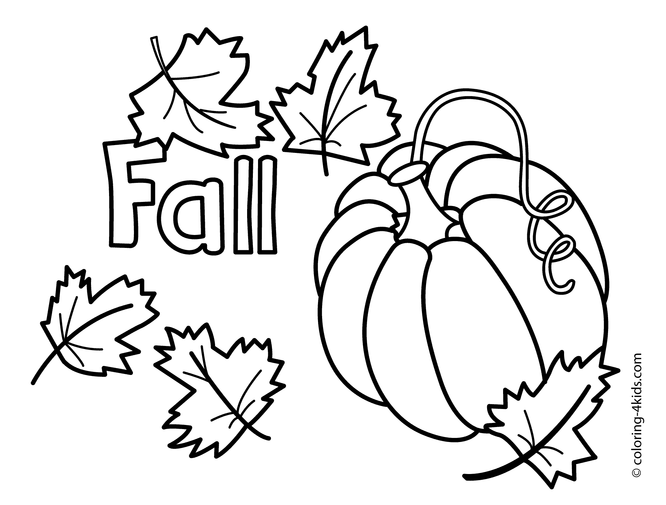

Age 0 – 6 Color Sheet

