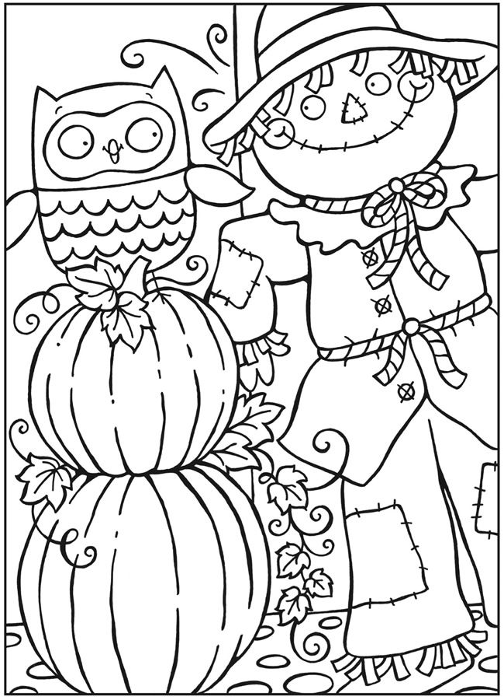

Age 7 – 10 Color Sheet

