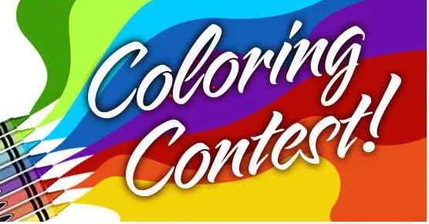

If you are a child up to 10 years old, you are invited to participate in
Greenville Public Library’s
Fall Coloring Contest!
Ask for a color sheet at the circulation desk or print one from our website, the city’s website, or WGEL’s website.
Our first age group is 0 – 6, and the second age group is 7 – 10. There are different color sheets for each group, so choose the correct one.
Entries need to be received no later than Wednesday, November 10th. Please put your name and phone number on a separate piece of paper, so the judges won’t know who colored it. A winner from each group will win a prize.

