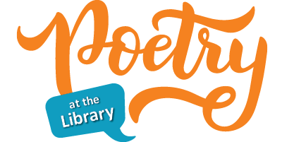

Earth Day isn’t the only holiday in April; it is also National Poetry Month. The Greenville Public Library will be celebrating by hosting a poetry contest for children. There will be three age groups: 3rd – 5th grade, 6th – 8th grade, and high school students.

The theme for our poetry contest is NATURE. Poems can be about anything associated with nature. All entries need to be received no later than Saturday, April 27th.

Age Groups:

3rd – 5th: up to 20 lines

6th – 8th: up to 20 lines

High School Students: up to 40 lines

The contest will be judged blind. Make sure your name does not appear on the page with your poem. Include the Permission to Publish form, which can be downloaded on our website or picked up at the library. Typed or handwritten submissions will be accepted. We will not be returning poems, so make sure to send us a copy, not the original. Poems and Permission to Publish forms may be mailed, delivered to the library, or put in our drop box. Items may also be emailed to the library at greenvillepubliclibrary414@gmail.com.

The best poem from the two younger age groups will win a $15 gift card to a business of his/her choice in town. The best poem from the high school entries will win a $25 gift card to a business of his/her choice in town.

The contest will be judged by Dr. Sandra Salguero Schmidt, who was a professor of English for 42 years, 29 of those years at Greenville University. She has a B.A. in English and Education from the University of Puerto Rico, an M.A. in English Language and Literature from Central Michigan University, and a PhD in Second Language Acquisition and Teacher Education from the University of Illinois.