Come to the
Greenville Public Library for
Illinois State Library’s Annual
Family Reading Night!

Thursday, November 17th
7:00 – 7:45 p.m.
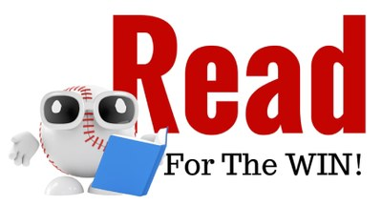

Listen, sing, and create with

Princess Lugge and

Mrs. Mains.

See you at the library!

