Hey, Ice Cream for Books participants…

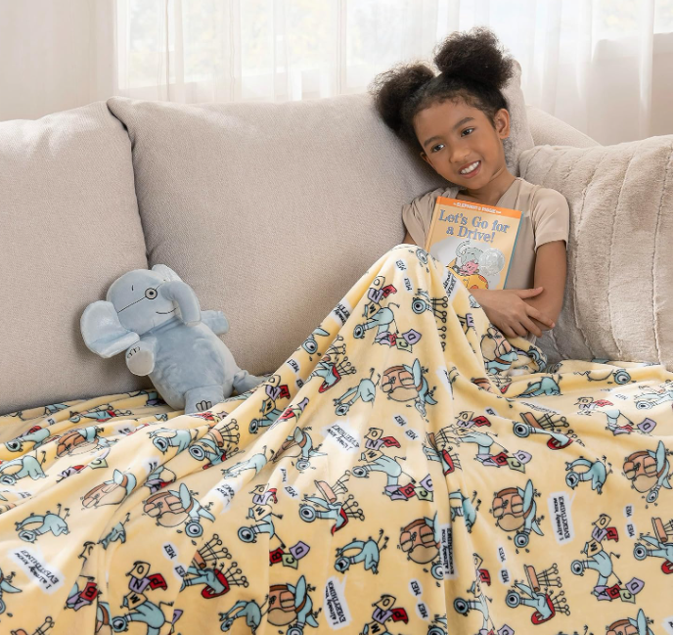

Earn at least 7 Dilly Bar coupons this summer to be entered in the

TOP READER drawing.

You could win a cozy Mo Willems Pigeon blanket!